Adjective Photographers
Sylvia Plachy:
Adjectives:
- Scared
- Lonely
- Cold
I picked these adjectives because they describe the man sitting on the train. In the picture everyone has big jackets on which I presume means it is cold outside. And this man is by himself and is under a blanket which I believe means he is a lone and scared of what is to come.
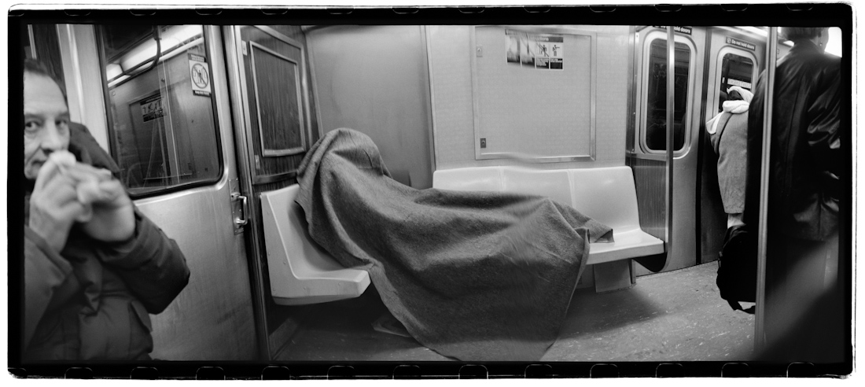

Philip-Lorca Dicorcia:
Adjectives:
- Strange
- Abnormal
- Alone
I picked these adjectives because it is very strange to see someone sitting on a subway holding a goldfish. He is also by himself and he only has one goldfish so that is why I picked the adjective alone. And to me he looks very abnormal. He has weird features.
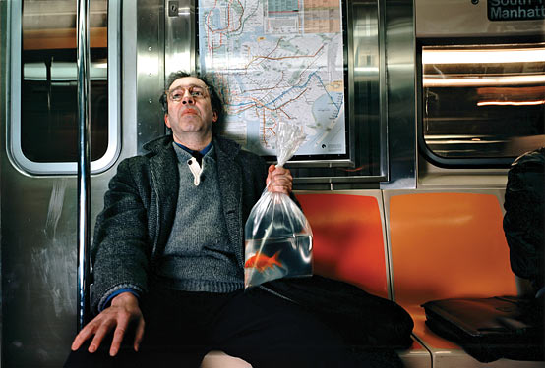

Gregory Crewdson:
Adjectives:
- Lonely
- Desperate
- Melancholy
I picked these adjectives because she is all alone and by herself. She is also looks sad and desperate.
